**36. Design NFA using a simulator to accept the string the starts with a and ends with b over the set {a,b} and check whether W= abaab is accepted or not.**

**AIM:** To Design NFA using a simulator to accept the string the start with a and end with b over set {a,b} and check whether W= abaab is accepted or not.

**TRANSITION DIAGRAM:**

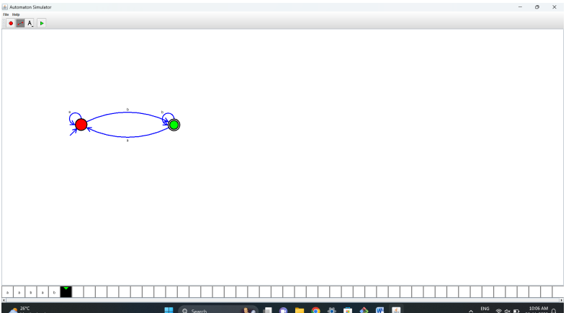

**RESULT**: Hence designing NFA using a simulator to accept the string whether w=abaab is accepted or not